### 1. Stable marriage problem. Gale-Shapley algorithm.

[14-6: Gale-Shapley 算法 寻找稳定婚配_哔哩哔哩_bilibili](https://www.bilibili.com/video/BV1uq4y177Hc/?spm_id_from=333.1007.top_right_bar_window_custom_collection.content.click)

### 2. Divide and conquer algorithms.

[2 Divide And Conquer (youtube.com)](https://www.youtube.com/watch?v=2Rr2tW9zvRg)

二分查找（binary search）：

[078_尚硅谷_二分查找算法思路图解_哔哩哔哩_bilibili](https://www.bilibili.com/video/BV1E4411H73v?p=78&vd_source=79e074aaa7c81905bda86f677ba122fc)

[2.6.1 Binary Search Iterative Method (youtube.com)](https://www.youtube.com/watch?v=C2apEw9pgtw&list=PLDN4rrl48XKpZkf03iYFl-O29szjTrs_O&index=30)

归并排序（mergesort）：

[069_尚硅谷_归并排序算法思路图解_哔哩哔哩_bilibili](https://www.bilibili.com/video/BV1E4411H73v?p=69&vd_source=79e074aaa7c81905bda86f677ba122fc)

[2.7.2. Merge Sort Algorithm (youtube.com)](https://www.youtube.com/watch?v=mB5HXBb_HY8&list=PLDN4rrl48XKpZkf03iYFl-O29szjTrs_O&index=34)

Master method：

[What is the Master Theorem? (youtube.com)](https://www.youtube.com/watch?v=2H0GKdrIowU)

[2.4.1 Masters Theorem in Algorithms for Dividing Function #1 (youtube.com)](https://www.youtube.com/watch?v=OynWkEj0S-s)

Strassen's fast matrix multiplication：

[2.9 Strassens Matrix Multiplication (youtube.com)](https://www.youtube.com/watch?v=0oJyNmEbS4w&list=PLDN4rrl48XKpZkf03iYFl-O29szjTrs_O&index=38)

### 3. Freivald's algorithm

### [Freivalds' Algorithm (youtube.com)](https://www.youtube.com/watch?v=3E5CZ9ytYAY)

### 6. Fast polynomial multiplication

https://www.youtube.com/watch?v=h7apO7q16V0&t=191s

# mid-exam

## 1-Stable marriage problem. -Gale-Shapley algorithm.

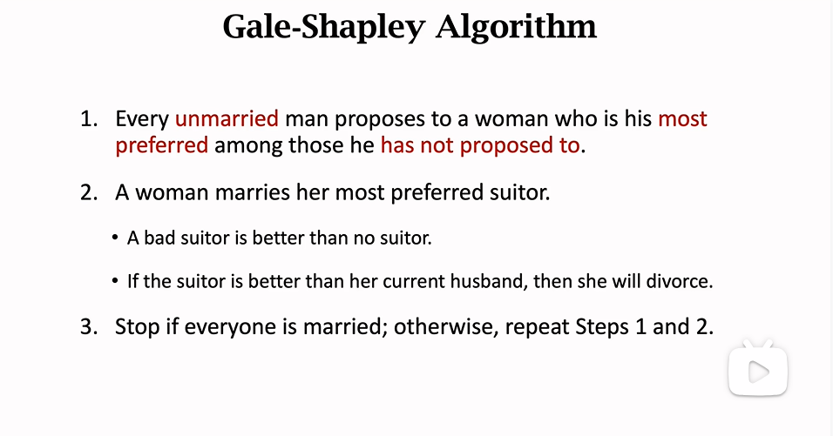

## 2-Divide and conquer algorithms.

## - binary search

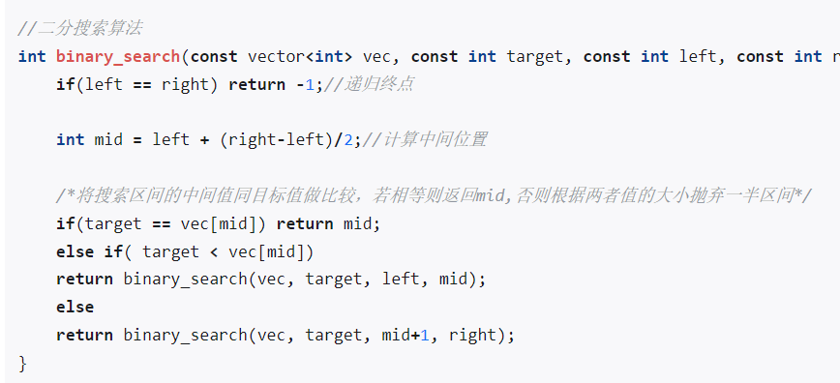

## - Merge sort

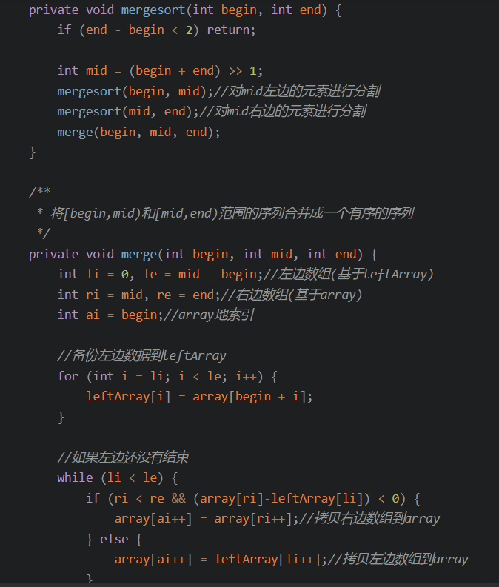

## - Master method.

## 3-Strassen's fast matrix multiplication.

## 4-Randomization.

## 5-Freivald's algorithm.

## 6-Fast polynomial multiplication (by FFT).

## 7-Dynamic programming. - Matrix chain multiplication.

https://zhuanlan.zhihu.com/p/563714882

# End-exam

## 8-Longest common subsequence.

Longest Common Substring

## 9-Optimal sequence alignment.

## 10-Knapsack problem.

表格

Change-making problem.

Greedy algorithms.

Scheduling problems.

Approximate algorithms.

Load balancing.